Create a simple cloud software application for Property Buying & Rental process (In Chennai city) using any Cloud Service Provider to demonstrate SaaS

Aim
To create a simple cloud-based Property Buying and Rental System for Chennai city using Zoho Creator to demonstrate the Software as a Service (SaaS) model.
Procedure
- Login to Zoho Creator and create a new application named Chennai Property Management System.
- Create a Property Details form with Property ID, Type, Location, Area, Price, and Status.
- Add property types such as House, Apartment, Villa, and Commercial Property.
- Create an Owner Details form with Owner Name, Contact Number, and Email.
- Create a Customer Details form with Customer Name, Contact Number, Email, and Requirement.
- Create a Buying/Rental Request form to select the property and transaction type.
- Add workflows to update the property status as Available, Sold, or Rented.
- Create reports to display available properties and customer requests.
- Create a dashboard to view property availability, sales, and rental information.
- Test and deploy the application through the cloud, demonstrating SaaS.
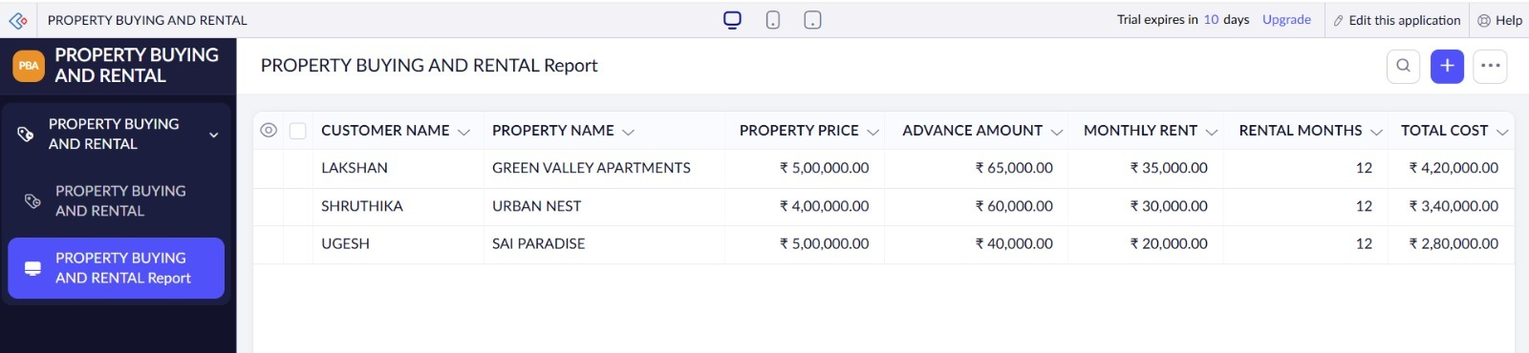
Result
A cloud-based Property Buying and Rental System for Chennai was successfully created using Zoho Creator.

